Homework #5

1. Principal Component Analysis

a.



b.



c.

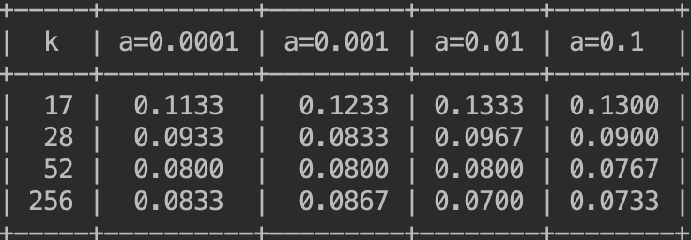

d.

Test error of the best pair (52, 0.1) with features selection: 0.0833

Test error of the best pair (256, 0.01) without features selection: 0.0767

Comparing to the performance of the SVM without feature selection, the test error has little difference. It shows that PCA actually does a good job. Although we reduce many dimensionalities, the performance does not change a lot.

2. Spectral Clustering

c.



d.





When γ = 27, spectral clustering outperforms k-means clustering.

e.

The graphs show the segmented images produced by both approaches.



When γ = 0.1000, spectral clustering outperforms k-means clustering.



When γ = 1.0000, spectral clustering performs worse.